Services & Daemons
Daemons are programs that run in the background performing various tasks.

Start and Stop services
# systemctl start crond
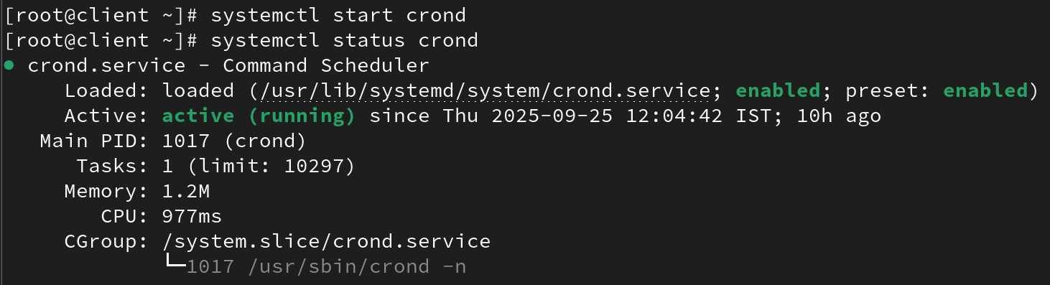
# systemctl stop crond
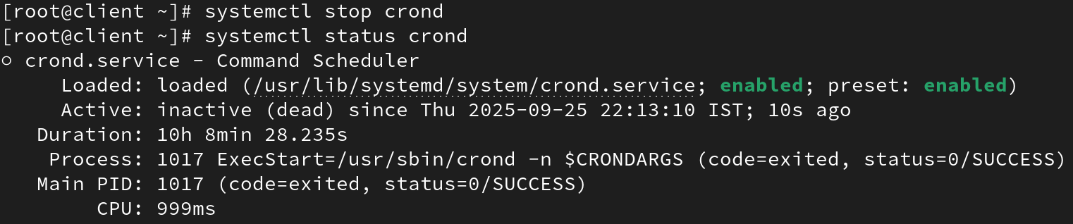

Restart and Reload services
# systemctl restart crond
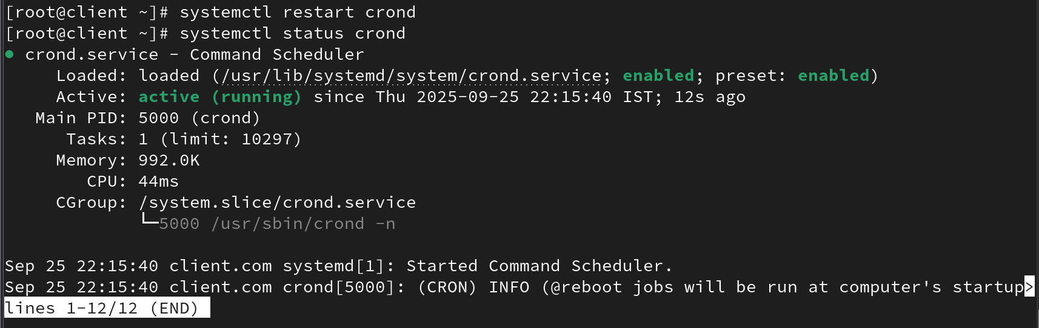
To reload all the configuration files forcefully on your system:
# systemctl reload crond
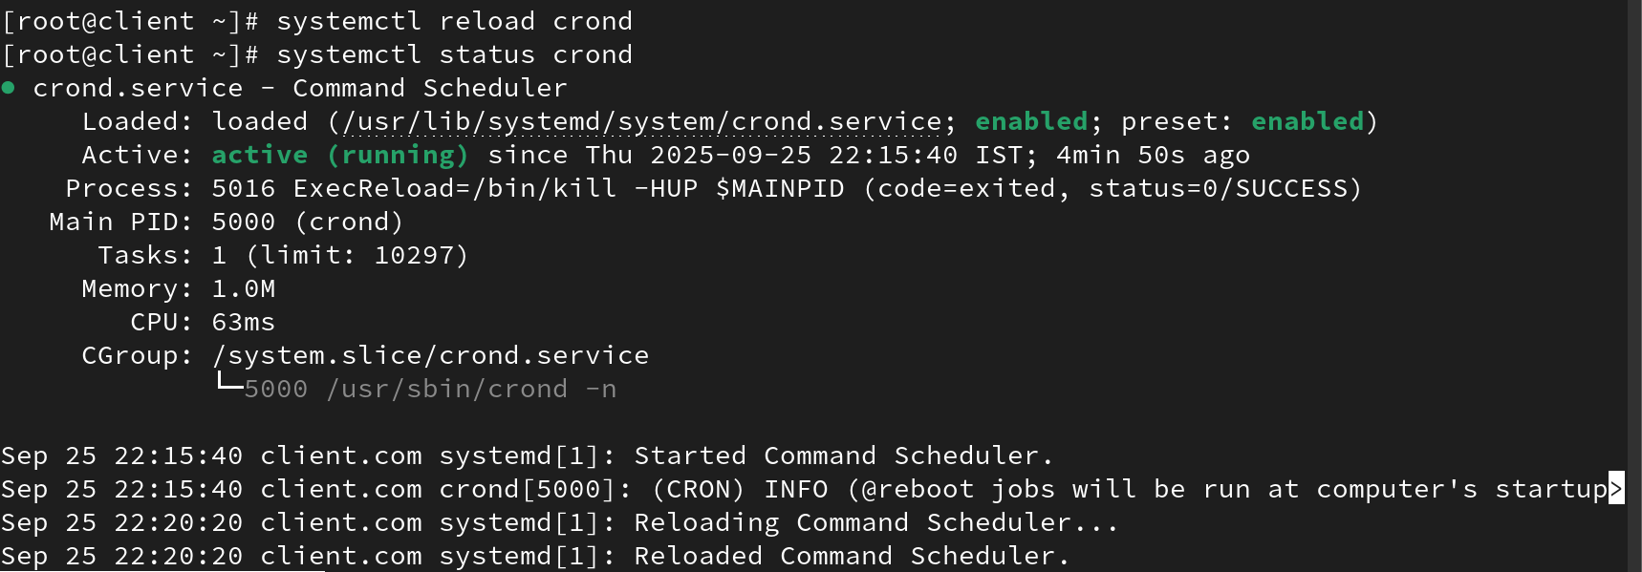

To view complete log
#systemctl journal -xeu service name
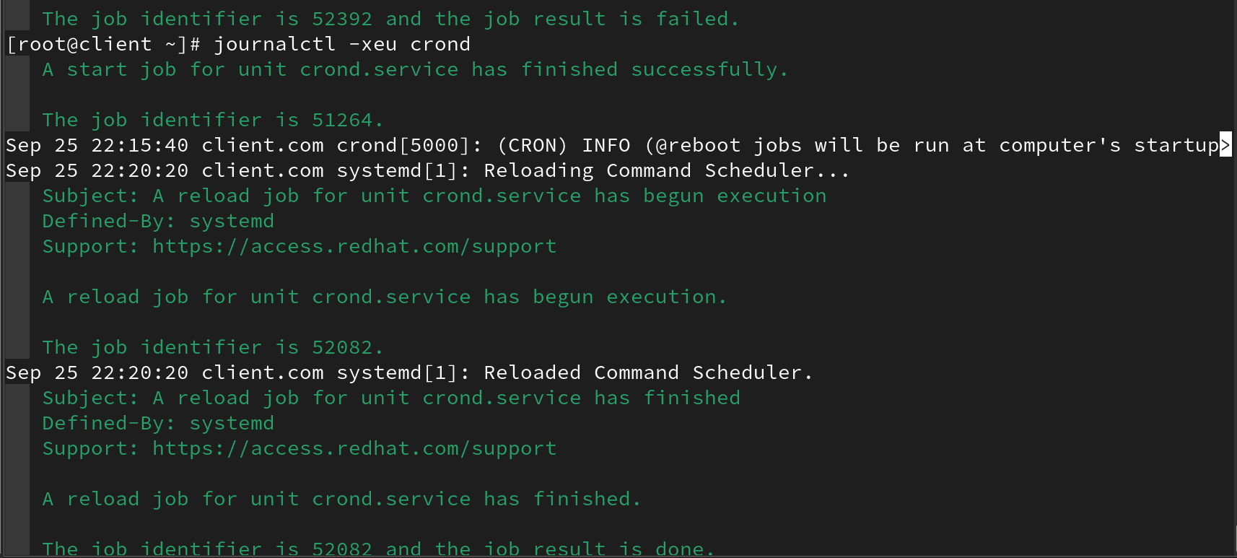

Enable and Disable services
# systemctl enable crond
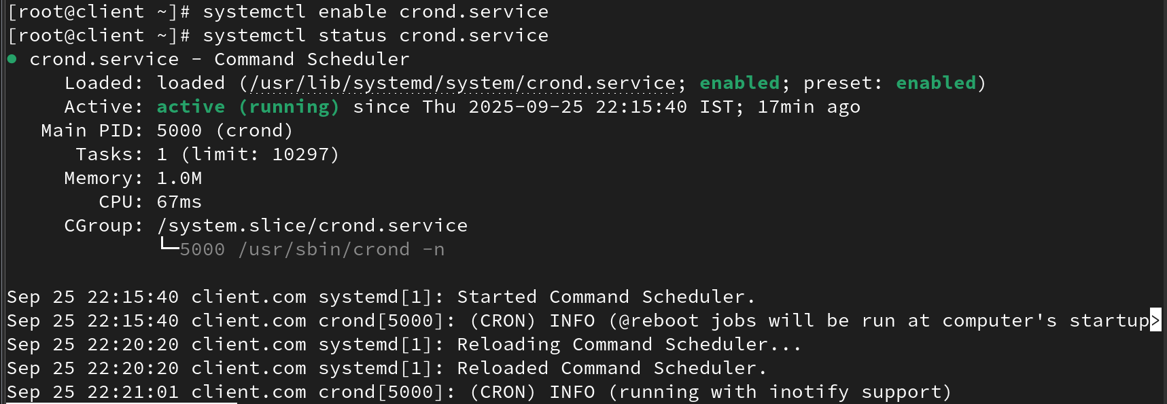
# systemctl disable crond
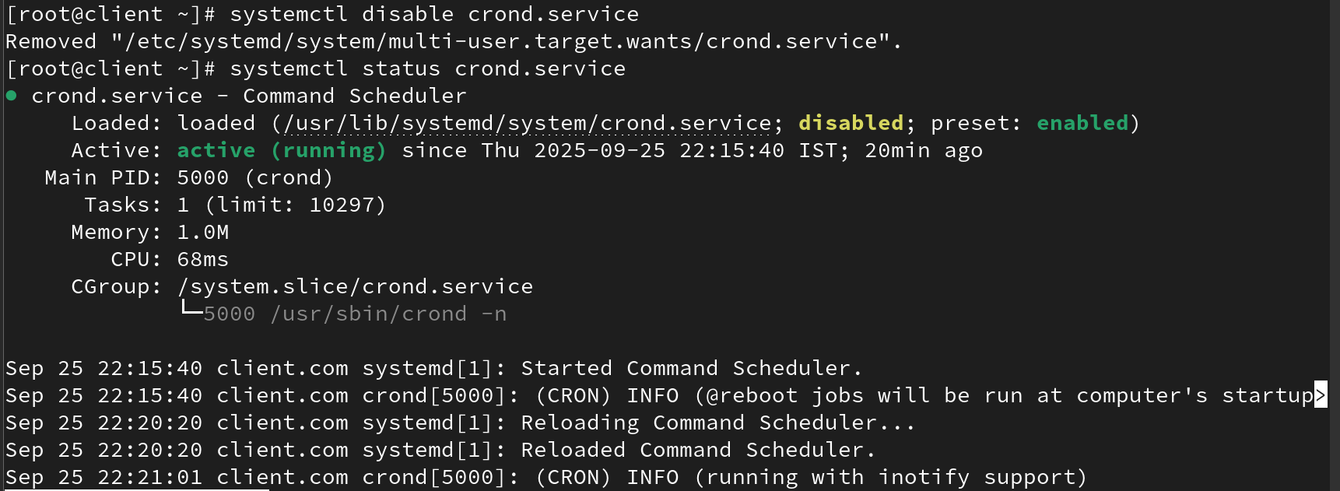

To permanently enable or disable:
# systemctl enable sshd –now
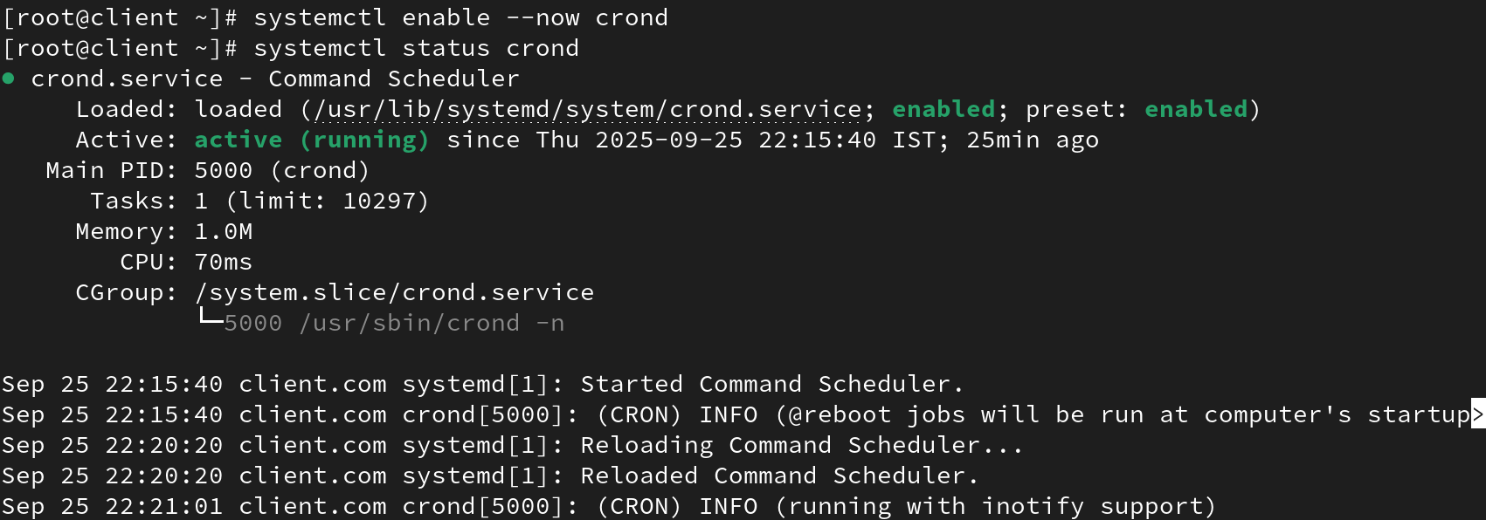
# systemctl disable sshd –now
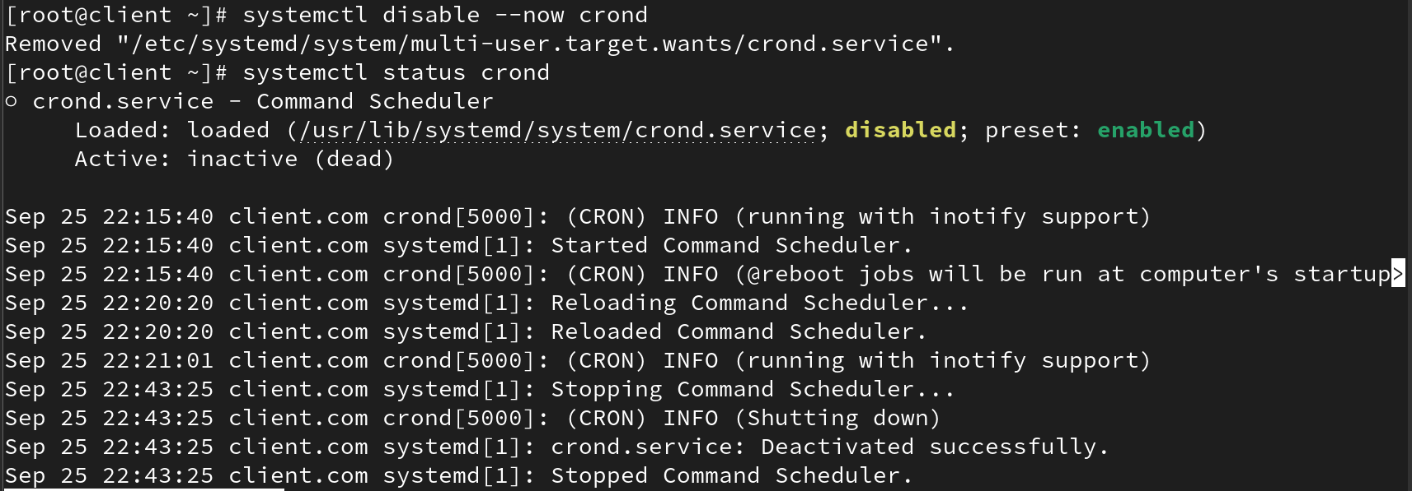
# systemctl is-active sshd
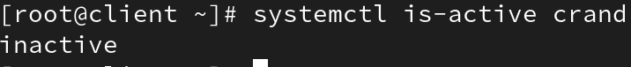
# systemctl is-enabled sshd
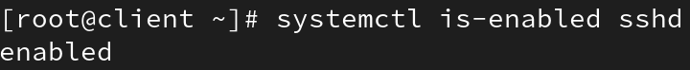

List Services
List all services:
# systemctl list-units --type service –all
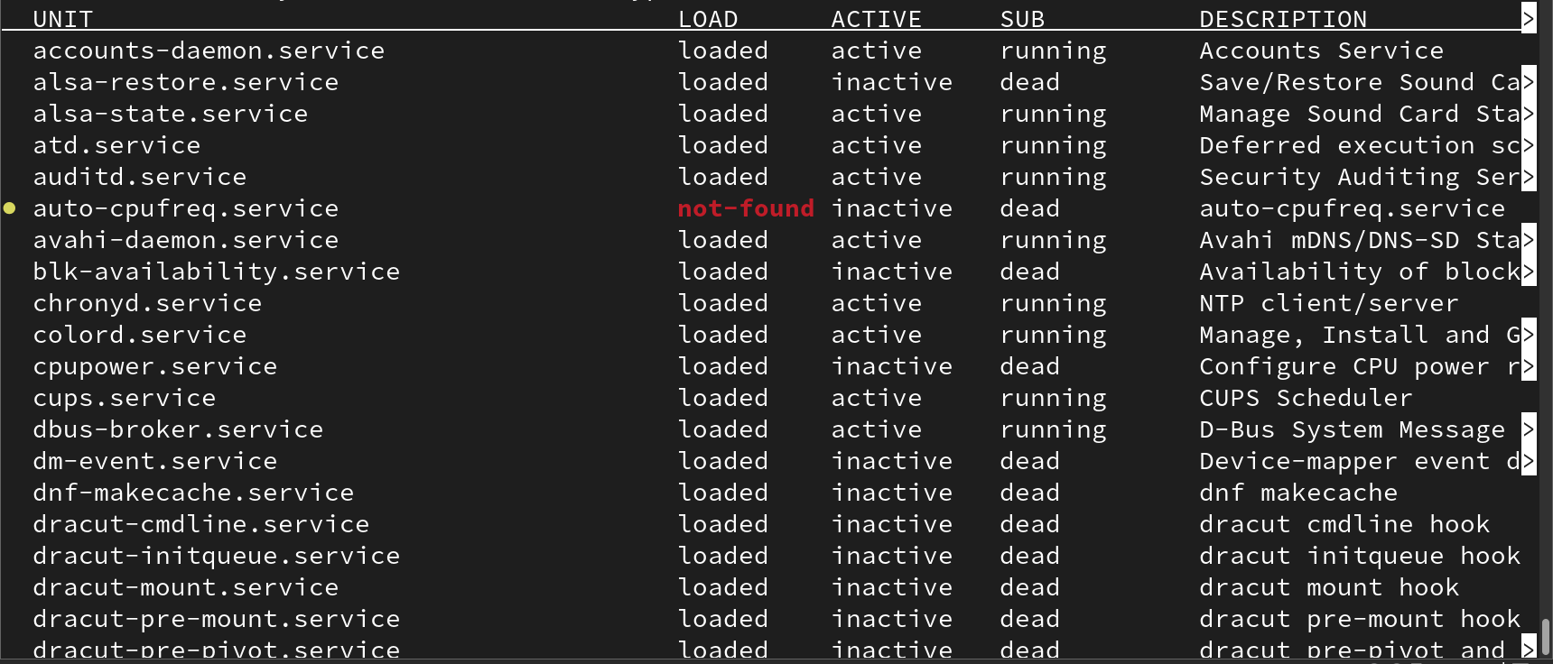
# systemctl list-unit-files --type=service
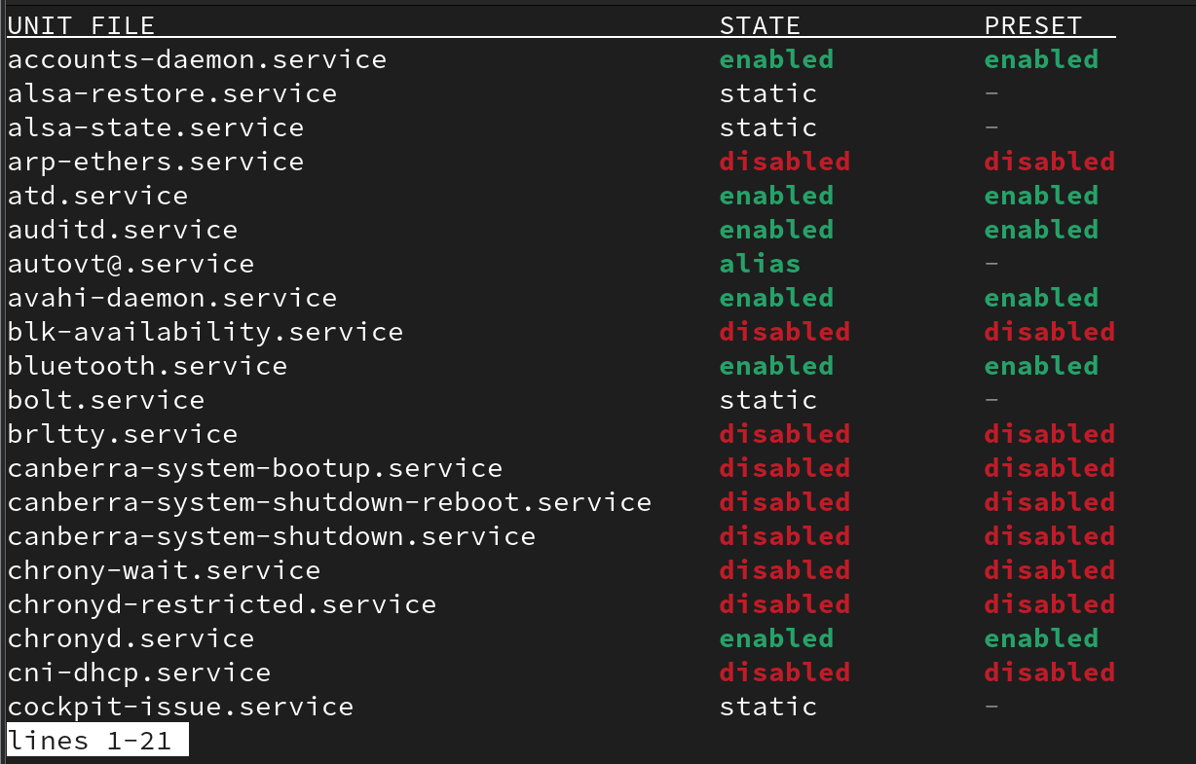
List of services that are active now:
# systemctl -t service

